PRINTS & CARDS ORDER FORM
Dochas Centre
Artwork by the late John R Paterson.

Dochas Centre offers free information, guidance and support to unpaid carers in Argyll. John, co-founder of the Dochas Fund, was diagnosed with MND and GBS. Before his death in 1998, he asked that his art be used to help raise money for people affected by MND and GBS.
- Colour Reproductions
Greetings Card – 15 x 20 cm, with envelope £ 2.00
Miniature Print – approx. 25 x 30 cm, framed £30.00
Limited Edition Print – approx. 30 x 50 cm, mounted £75.00
- Pen & Ink Reproductions
Greetings card – 10 x 15 cm, with envelope £ 2.00
Miniature Print – approx. 30 x 40, mounted £10.00
- Book
Creativity: the true art of therapy
A biography of John Paterson’s life and a guide to his exhibited work £10.00
Please indicate the quantity you would like to purchase in each column
DESCRIPTION | Card | Print | Limited
A PERFECT DAY
ANCIENT LAND
ARRAN NO.1
BELLANOCH
CERISE
COME ON AND CELEBRATE
CRINAN BASIN
CRINAN HARBOUR
EMERGING IMAGE
FOR MUM
FOSSIL CLIFFS
HILLS AT ARROCHAR
IMPRESSION
LONG WALK
PREHISTORIC NORFOLK
SEA LOCK, CRINAN
SHEPHERDS’ DELIGHT
SPACE IN BETWEEN
UNTITLED
UNTITLED FLOWERS
WALKING AWAY
WATERS OF ARGYLL
PEN & INK NO.1
PEN & INK NO.2
PEN & INK NO.3
PEN & INK NO.4
BOOK – Creativity: The True Art Of Therapy

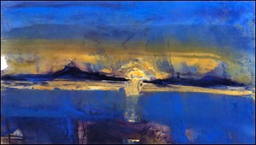 | 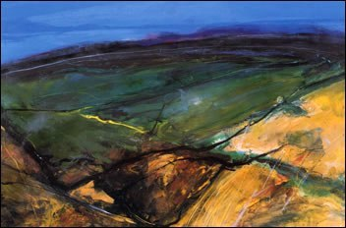 | 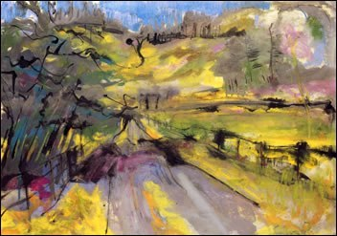 | 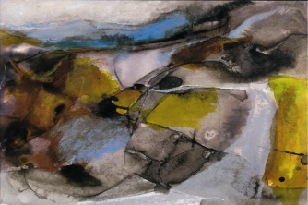
A perfect day | Ancient Land | Arran No.1 | Bellanoch
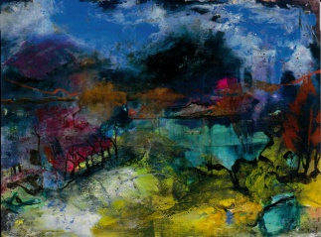 | 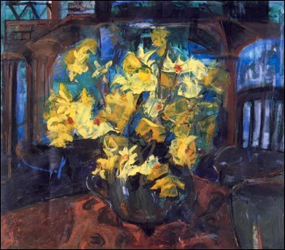 | 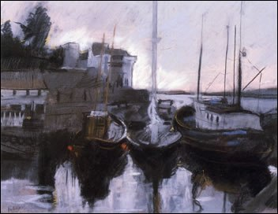 | 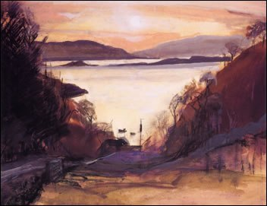
Cerise | Come on & celebrate | Crinan Basin | Crinan Harbour
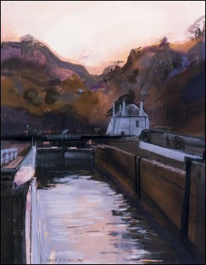 | 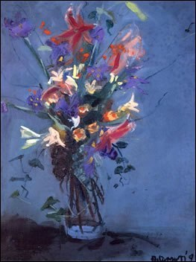 | 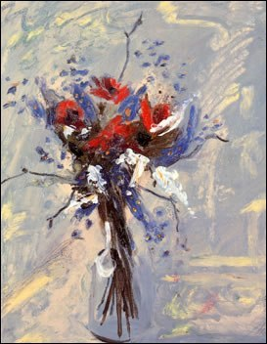 | 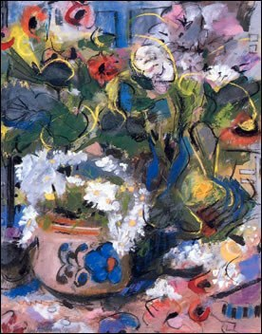
Sea Lock, Crinan | For Mum | Impression | Untitled Flowers
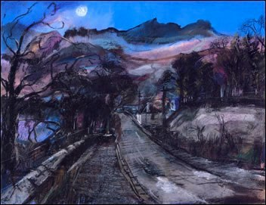 | 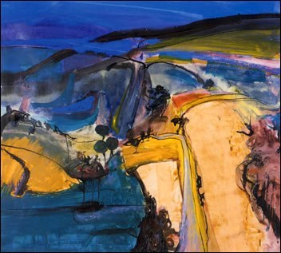 | 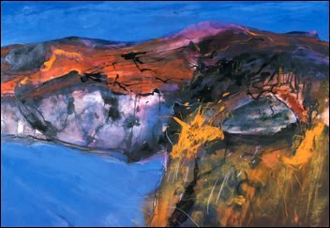 | 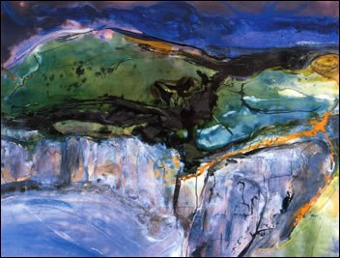
Hills at Arrochar | Long Walk | Prehistoric Norfolk | Fossil Cliffs
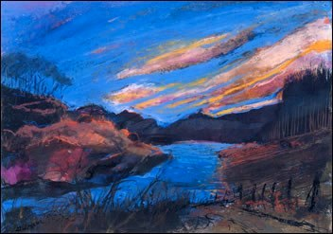 | 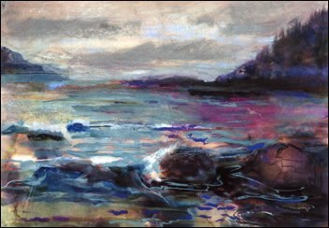 | 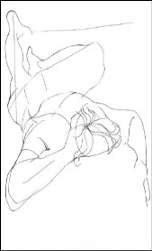  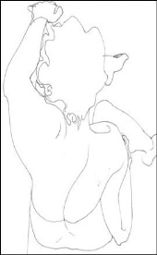 | 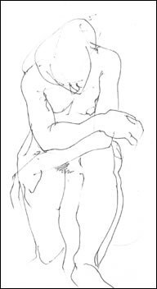
Shepherds’ Delight | Waters of Argyll | Pen & Ink No.1 & 2 | Pen & Ink No.3 & 4
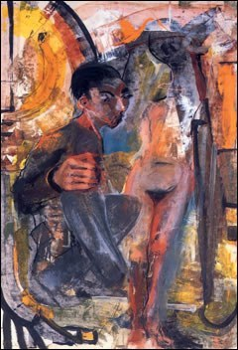 | 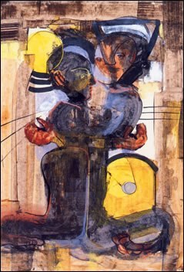 | 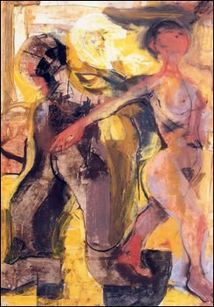 | 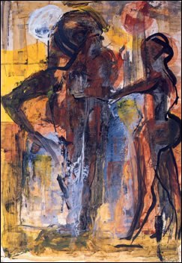
Emerging Image | Space in Between | Walking Away | Untitled

Please add 10% for postage and packing within the UK. Outside the UK contact us for the cost of postage and packing charges. Dochas Centre Telephone +44 (1546) 600 022
Payment Details
If paying by UK cheque or postal order, please make it payable to “Dochas Fund”.
If paying by bank transfer, details are
Bank: Bank of Scotland
Account name: The Dochas Fund
Account number : 00131786
Sort code: 80-08-86
Delivery Details
Name: ____________________________________________________________________
Address: __________________________________________________________________
______________________________________Post code: ___________________________
Contact Tel: ________________________________________________________________
Email: _____________________________________________________________________

Items will be dispatched within 7 days of receipt of payment. Please send the completed order form to: Dochas Centre, 50 Campbell Street, Lochgilphead PA31 8JU
Tel: 01546 600 022 / E-mail: enquiries@dochasfund.org.uk/ www.dochasfund.org.uk

Thank you for your order

